

**System Design & Development Report**

**for Undergraduate Major Project: CanScan**

**2025 -2026**

**By**

**HARDIK SHAH (2241131)**

**HIMANSHI AGARWAL (2241132)**

**Bachelor of Computer Applications**

**Under the supervision of**

**Dr. Newbegin Luke**

1. **Architectural design**
   1. **3 Tier-ed Architecture**
   2. **Subsystems**
   3. **Image Capture and Analysis**

**Description**:  
CanScan allows users to capture high-resolution images of skin lesions or moles using their smartphone cameras. The application guides users with prompts to ensure proper lighting, focus, and framing to optimize image quality.

**Detailed Process**:

* Users take a picture of the lesion or select a previously saved image.
* The app applies pre-processing filters to enhance clarity and remove noise.
* The machine learning model analyzes the image, extracting key features based on the ABCD criteria; **Asymmetry**: Compares one half of the lesion to the other, **Border**: Identifies uneven, blurred, or jagged lesion edges, **Colour Variation**: Detects multiple shades within the lesion, **Diameter**: Measures the lesion size to identify if it exceeds a risk threshold.
  1. **Risk Assessment and Recommendation Engine**

**Description**:  
The application classifies lesions into risk categories: **Low, Moderate, or High**. A personalized health path recommendation follows, advising users on next steps.

**Detailed Process**:

* Low risk: Suggests monitoring with periodic image capture.
* Moderate risk: Encourages users to consult a dermatologist for a professional opinion.
* High risk: Advises immediate medical attention.
  1. **User-Friendly Interface**

**Description**:  
The interface is designed for ease of use with clear instructions and a clean layout.

**Key Features**:

* **Guided Image Capture**: Step-by-step prompts for capturing quality images.
* **Dashboard Overview**: Displays risk scores, lesion history, and recommended actions.
* **Educational Resources**: Interactive content on skin cancer prevention and self-examination techniques.
  1. **Blockchain-Based Data Storage**

**Description**:  
Blockchain technology provides secure, decentralized data storage for users' medical data and images.

**Detailed Process**:

* **Decentralized Storage**: User data (images, risk assessments, and history) is stored on a blockchain ledger, ensuring data integrity and preventing unauthorized modifications.
* **Privacy and Security**: Data is encrypted, and access is restricted through private keys controlled by the user.
* **Transparency and Ownership**: Users maintain ownership of their data and control permissions for sharing with healthcare providers.
* **Immutability**: Blockchain ensures that data cannot be altered retroactively, reinforcing trust in diagnostic history and recommendations.

1. **Dataflow Diagram**
   1. **DFD Level-0**

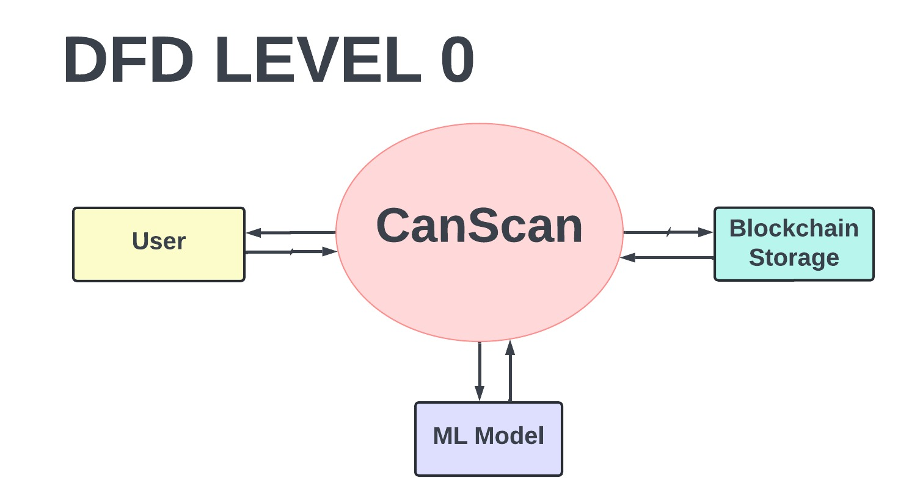

* 1. **DFD Level-1**

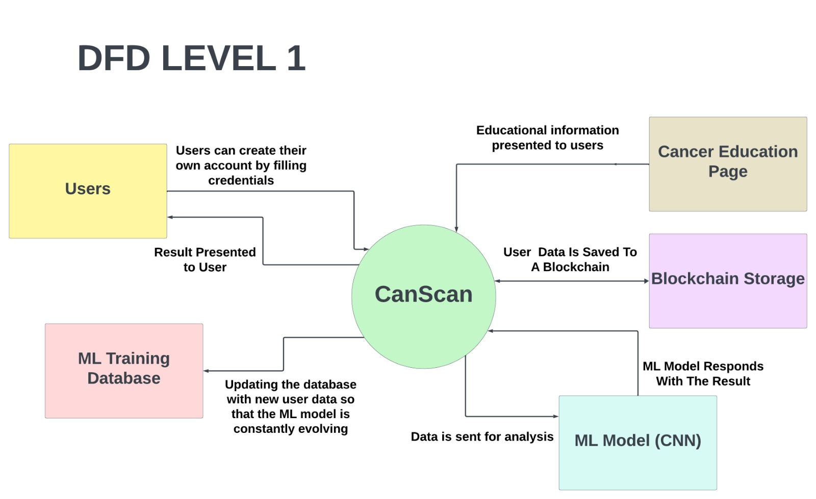

1. **Database Design**
   1. **Class Diagram**

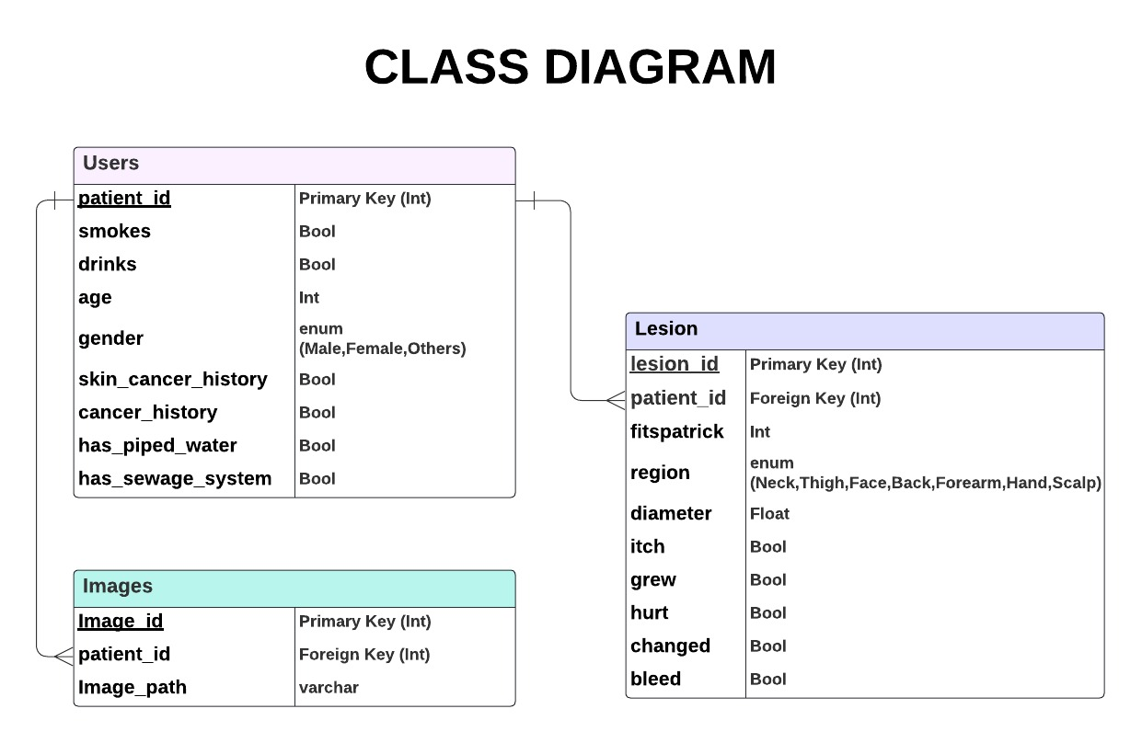

* 1. **Database Screenshot**



* 1. **Column Details**
     1. **patient_id**: Identifier of the patient under study.
     2. **smoke**: Whether the patient has a history of smoking or not.
     3. **drink**: Whether the patient has a history of alcohol consumption or not.
     4. **age**: Age of the patient at the time of examination.
     5. **pesticide**: Whether the patient has been exposed to pesticides or other chemicals.
     6. **gender**: Gender of the patient.
     7. **skin_cancer_history**: History of skin cancer in the patient's family.
     8. **cancer_history**: History of cancer in the patient's family.
     9. **has_piped_water**: Indicates whether the location or area of the patient's residence has access to piped water or not.
     10. **has_sewage_system**: Indicates whether the location or area of the patient's residence has a proper sewage system or not.
     11. **Fitzpatrick**: Skin tolerance to sunlight.
     12. **region**: The area of the body where the lesion or wound has been examined.
     13. **diameter_1**: Primary diameter of the lesion or wound.
     14. **diagnostic**: The type of lesion or wound is diagnosed.
     15. **itch**: Whether the lesion or wound has itched or not.
     16. **grew**: Whether the size of the lesion or wound has grown or not.
     17. **hurt**: Whether the lesion or wound has hurt or not.
     18. **changed**: Whether the appearance of the lesion or wound has changed or not.
     19. **bleed**: Whether the lesion or wound has bled or not.
     20. **img_id**: Identifier of the image related to the lesion or wound.



* 1. **Database File (EDA Complete):**